**CONTENTS**

1. Introduction .......................................................................................................................3
2. Purpose ..............................................................................................................................3
3. .Net Basic ...........................................................................................................................3
4. Microsoft Visual Studio ......................................................................................................3
5. SLN File ...............................................................................................................................3
   1. How to Create SLN File ................................................................................................3
6. How to Build .Net Application by Visual Studio .................................................................4
7. How to Build .Net Application by asp compiler exe ...........................................................5
8. FxCop ..................................................................................................................................6

6.1 Code Analysis by FxCop .....................................................................................................7

***INTRODUCTION***

In this Document I am going to Build the .Net Application source code through Asp Compiler Exe. And, I am going to use **FxCop** for code Analysis. Here I have a dummy .Net project which is cloned from Bitbucket. Here already I have installed Microsoft Visual Studio in my local system for building .Net Application.

***Purpose:***

This Annexure describe the activities like, how to build .Net Application source code by Asp Compiler Exe. And how-to Analysis the code by FxCop.

***What is .Net:***

**.Net** is a free cross-platform, open source developer platform for building many different types of applications.

***Microsoft Visual Studio:***

Microsoft Visual Studio is an integrated development environment from Microsoft. It is used to develop computer programs, as well as web sites.

***What is SLN File:***

Solution file is a structural file used for organizing project in Microsoft Visual Studio. It contains text-based information about the project environment and project state.

When opened, the pre-Solution, Project, and post Solution information is read from the SLN file. This data is used to load the solution, projects within the solution, and any persisted information attached to the solution.

***How to create SLN File:***

For creating the SLN File You Have to follow some steps. You can create SLN File through Visual studio.

**Step1**:

First open Visual Studio -> Then click on **File** -> **New** -> **New Project** ->Then you will get below page.

**Image1**

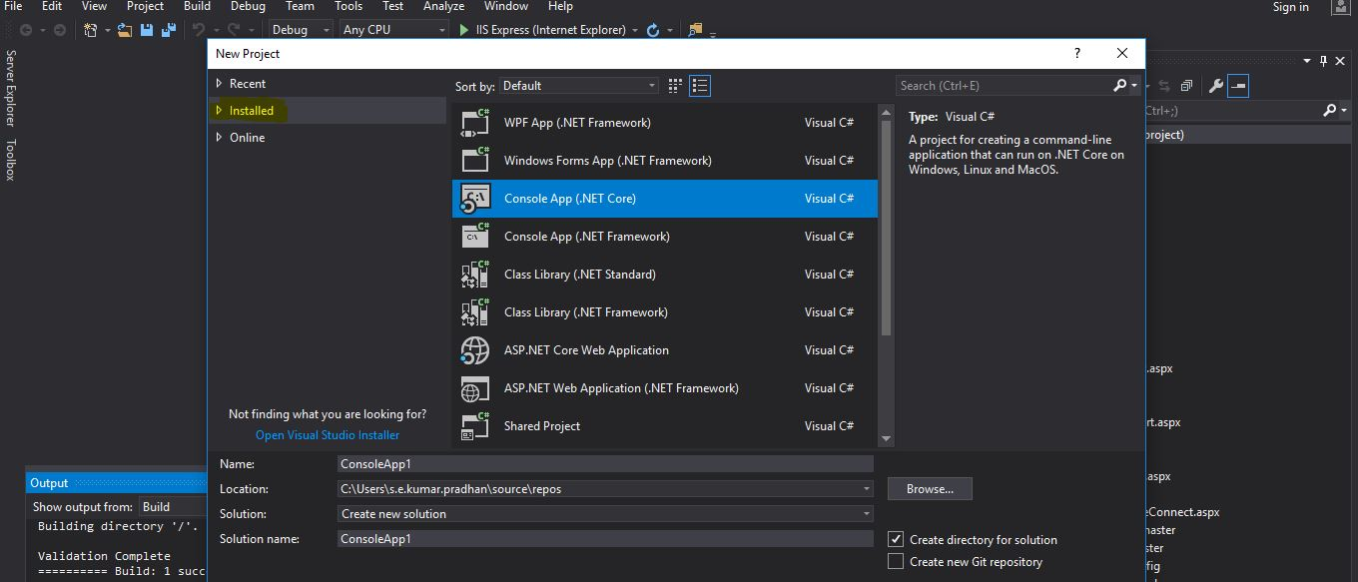

**Step2:**

Then expand **installed** -> Expand other **project type** -> Then select **visual studio solutions** -> Then under the column mention SLN File name and in location set your .Net project path -> Then click on **Ok** Button.

**Image2**

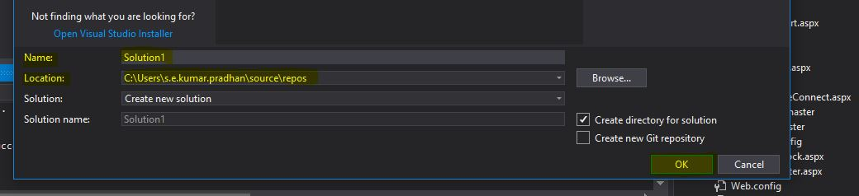

**Step3:**

Then go to your project path, you can see the SLN File.

**Image3**

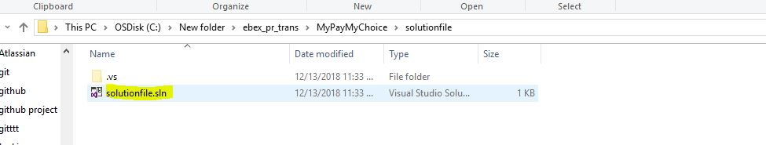

***How to Build .Net Application through Visual Studio:***

To Build the .Net Application in Visual Studio You Have to follow some steps like.

**Steps1:**

Open Visual studio -> go to file -> open -> The click on Web site -> The you can get below screen.

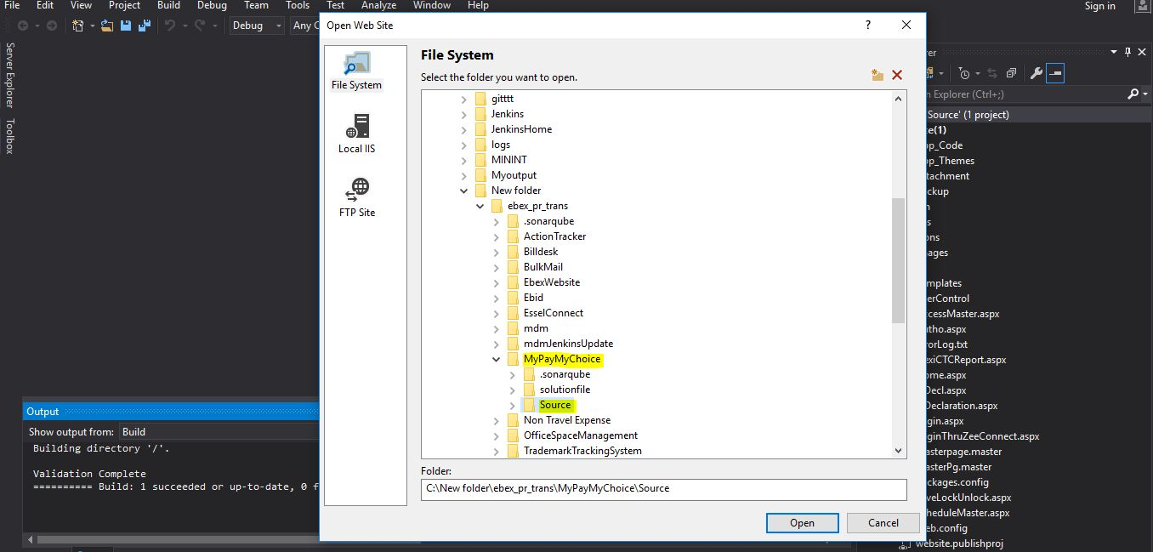

**Step2:**

Then choose your **Source** file of your project -> click on **Open.**

**Step3:**

Then right click on your project and click on **Build solution option**.

**Step4:**

The you can see the output in below.

**Image4**

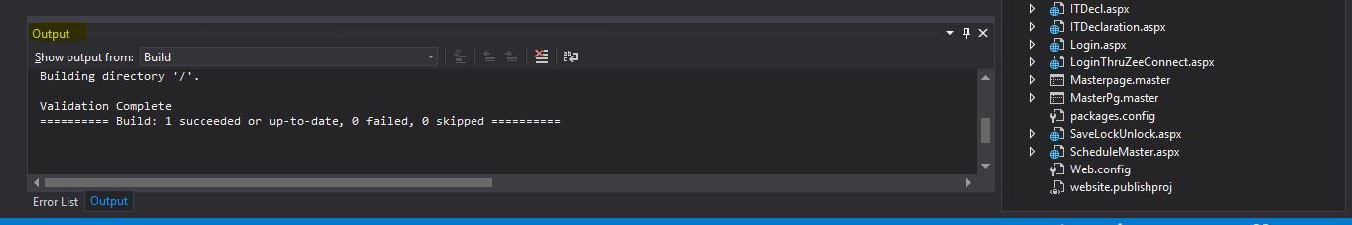

***How to Build .Net Application Source Code Through ASP Compiler Exe.:***

**Step1:**

First open command prompt. Then go to your project path.

**Image5**

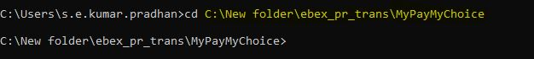

**Step2:**

Then type the below command to build the .Net Application.

C:\Windows\Microsoft.NET\Framework64\v4.0.30319\aspnet_compiler.exe -p "%PROJECT_ROOT%" /v /commerce site /u /f "%WEB_ROOT%”

**Image6**

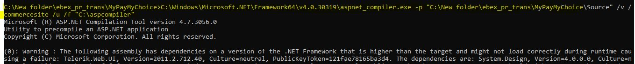

**Step3:**

Then Go to WEB_ROOT folder for getting the output.

***FxCops:***

FxCop is a code Analysis tool from Microsoft that analyzes managed .Net assemblies.

* FxCop provides a tool to help developers to follow their company's coding standards. FxCop does code analysis to check whether the new code is compliant with the coding standards and naming conventions followed by the company. FxCop will ensure that the specified rules are used in the source code.

***Code Analysis by FxCop:***

**Step1:**

First open your command prompt. Then go to the FxCop root path which is present in Microsoft Visual Studio.

Microsoft Visual Studio -> 2017 -> community -> Team Tools -> Static Analysis Tools -> FxCop

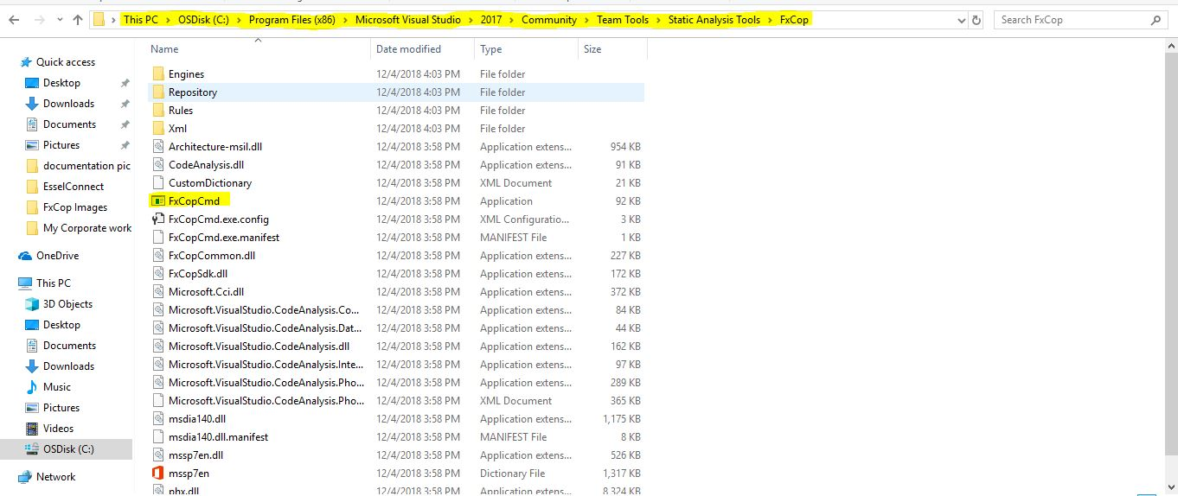

**Image7**



**Step2:**

Then In next step you Have to execute one more commands For Analysis the source code.

FxCopCmd.exe /file:E:\My\Project\Precompiled\bin

/rule:"C:\Program Files (x86)\Microsoft FxCop 1.35\Rules" /out:fxcopreport.xml

**Image8**



**Step3:**

Then you can see the status in below page.

**Image9**

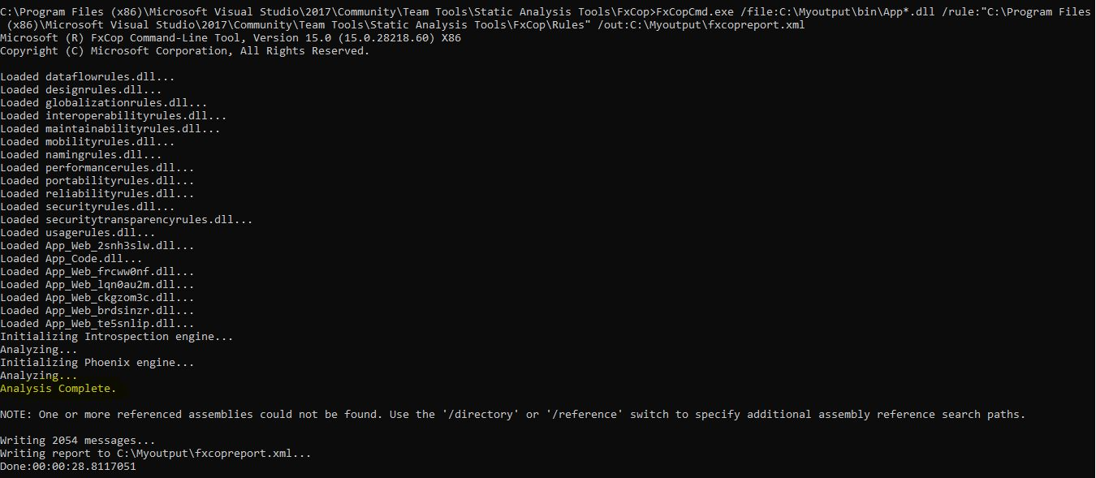

**Step4:**

Then go to the My Output Folder we can see the generate xml file.

**Image10**

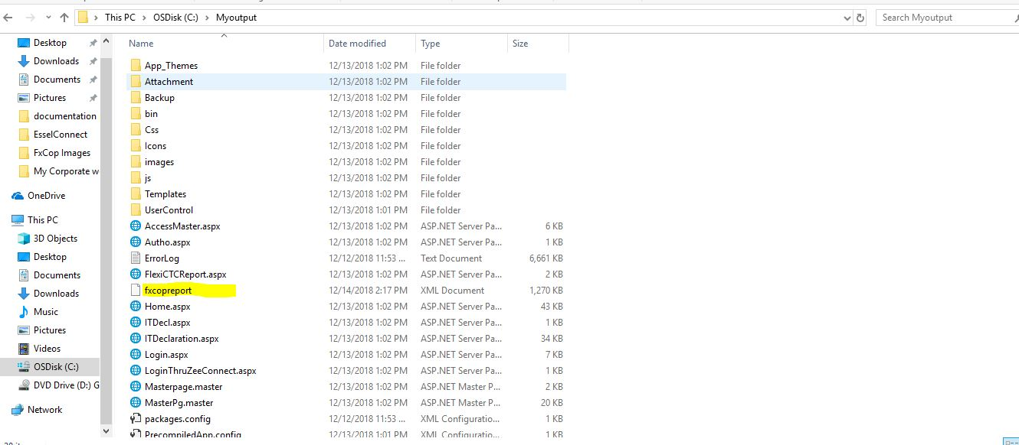

**Step5:**

Then open the Generate xml file by Note Pad++ and review the code Analysis as below page.

**Image11**

